National University of Computer and Emerging Sciences



Laboratory Manuals
for
Computer Networks

(CL -3001)

Course Instructor | Ms. Umme Ammara
Lab Instructor | Ms. Sarah Abid Khan
Section | BDS-8A
Semester | Spring 2025

Department of Computer Science FAST-NU, Lahore, Pakistan

Lab Manual 04

Objective:
- Analyzing the FTP packets using Wireshark
- Analyzing the ICMP packets using Wireshark

Lab Statement 1: Capturing FTP packets using Wireshark (10)

Step 1: Start a Wireshark capture.
- Close all unnecessary network traffic, such as the web browser, to limit the amount traffic during the Wireshark capture.
- Start the Wireshark capture.

Step 2: Download the .txt file.
- From the command prompt, enter ftp ftp.mcafee.com
- Log into the FTP site for mcafee.com with user anonymous and no password.
- Locate and download any .txt file.

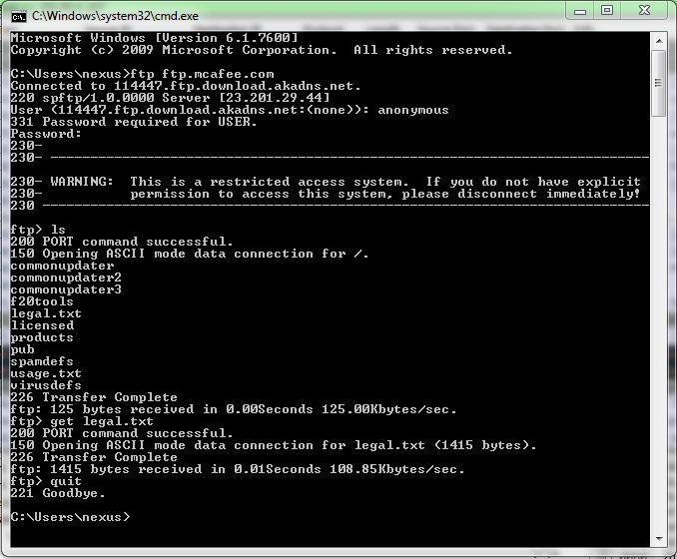

Step 3: Stop the Wireshark capture.

Step 4: View the Wireshark Main Window
Wireshark captured many packets during the FTP session to ftp.mcafee.com. To limit the amount of data for analysis, type tcp and ip.addr == 195.89.6.167 in the Filter. The IP address, 195.89.6.167, is the address for ftp.mcafee.com.

Step 5: Analyze the packets
Carefully analyze the packets in Wireshark windows and answer the following question:

Use the FTP_Session.pcapng (Wireshark Capture File) to answer the questions below

- FTP uses two port numbers: 20 and 21. Apply tcp.port==20 and tcp.port==21. Analyze the result and write down the purposes of these two ports for FTP.

Port 20: it is used to send data between client and server.
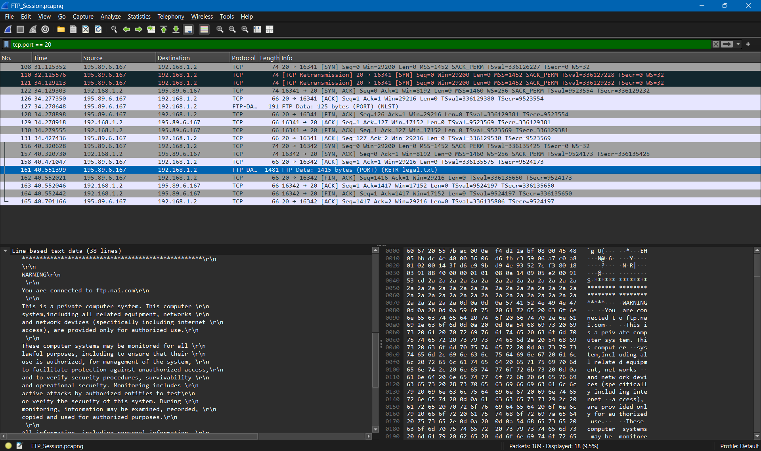
Port 21 is used by FTP to handle control channel. It is used by client to send commands like login credentials, directory navigation etc. that why we see “response” and “request” in packets.
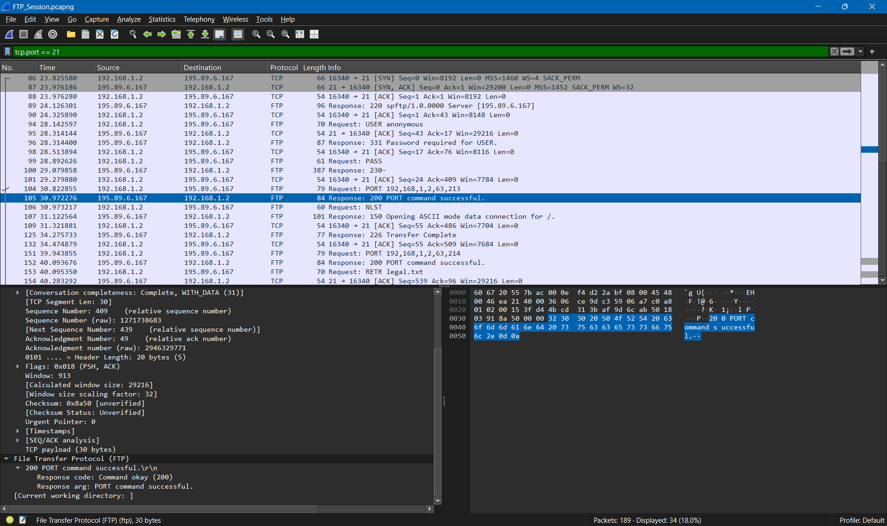
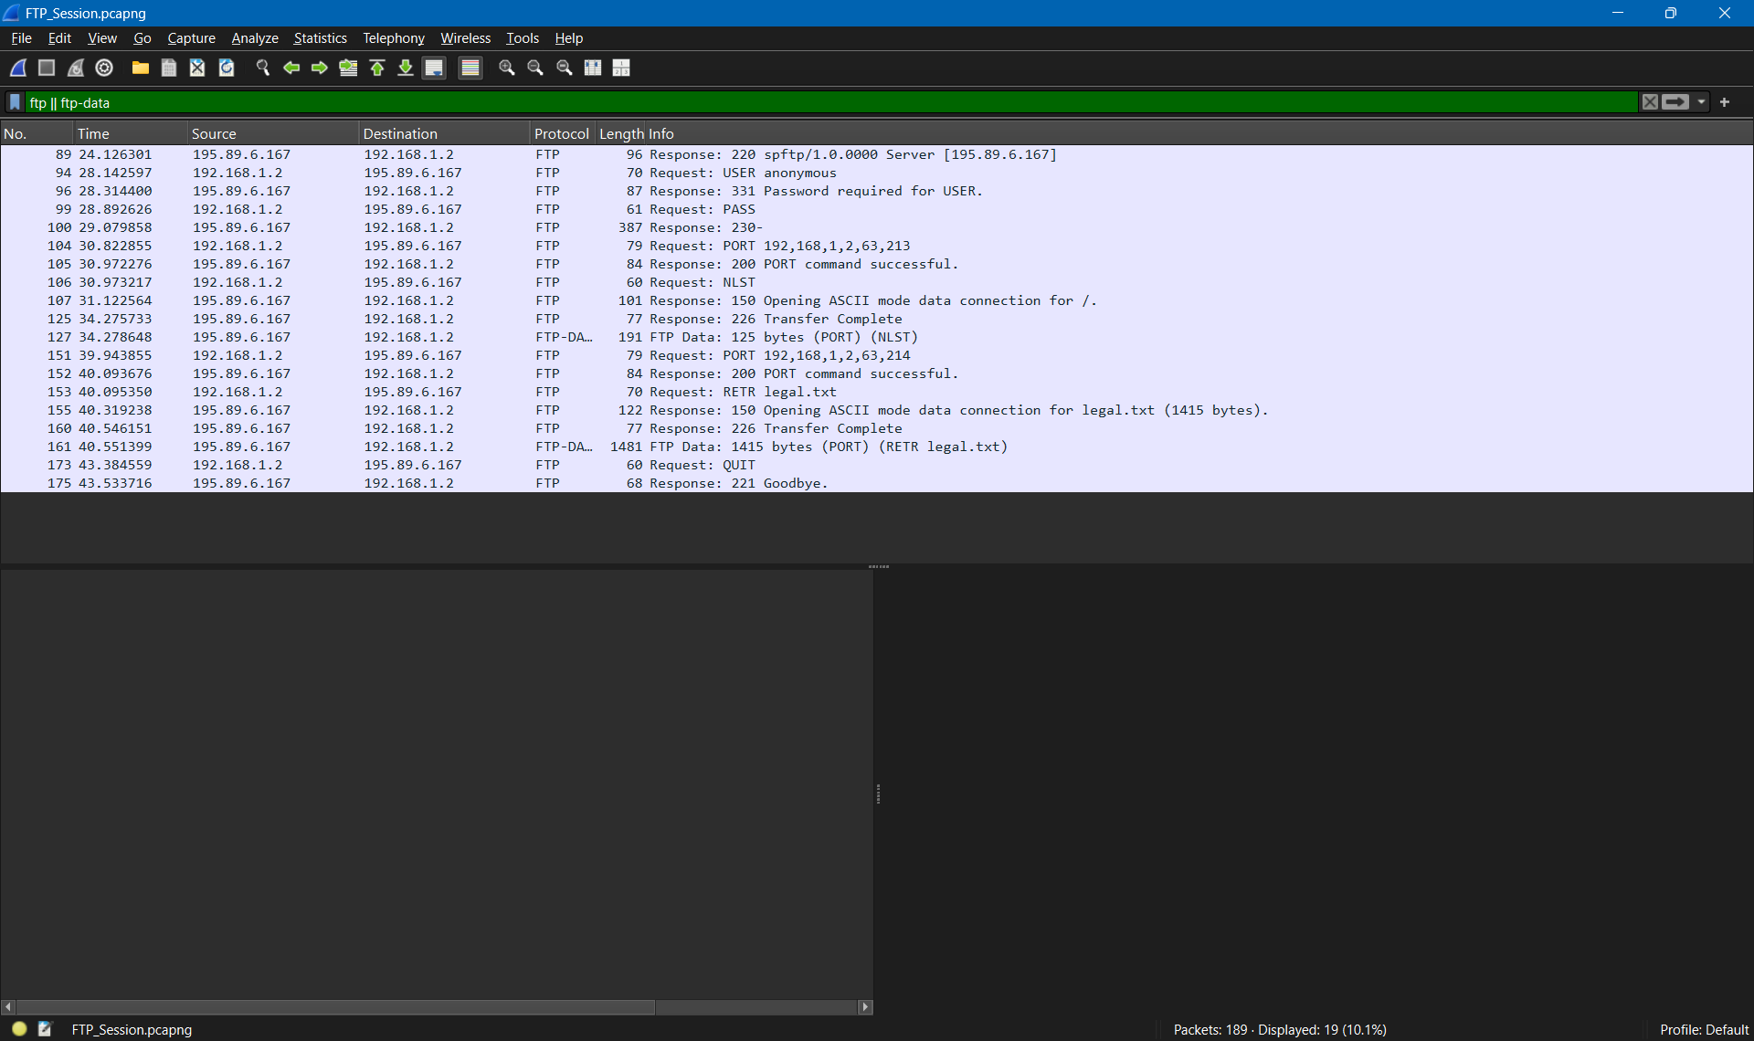
- Filter out each packet using either FTP or FTP-DATA Protocol (using ftp || ftp-data filter). Mention each packet number and its purpose with reference to request made and response received in the above mentioned FTP Session in command line to get file legal.txt
(screenshot show above). Also look for Response Code and Response Arg in the FTP Header for each packet
(There are 19 such packets and you have to write one/two lines explanation for each packet, what the packet is doing w.r.t FTP Session (Screenshot shown above) e.g., Packet 104: Client asks server to send the data on IP:192.168.1.2 and Port:16341 [63(0x3F),213(0xD5) and (0x3FD5=16341)] )

Total packets are 19
- Packet 89: Server sends FTP welcome message (220) “spftp/1.0.0000 Server [195.89.6.167]”
- Packet 94: Client sends username for authentication (Command USER anonymous).
- Packet 96: Server requests password for authentication (331): "Password required for USER."
- Packet 99: Client sends password for authentication (Command PASS).
- Packet 100: Server confirms successful login (230-): "230- [...]"
- Packet 104: Client asks server to send data (PORT) on IP: 192.168.1.2 and Port: 16341 [63,213 and 16341]
- Packet 105: Port command successful (200)
- Packet 106: Client sends the LIST command to request a directory listing (NLST)
- Packet 107: Server replies with (150) “150 Opening ASCII mode data connection for /” indicating that it is about to send data.
- Packet 125: Server sends (226) “226 Transfer complete” (directory listing for / successfully sent).
- Packet 127: [FTP‑DATA] First packet of the directory listing data transmitted on the data channel.
- Packet 151: Client asks server to send data (PORT) on IP: 192.168.1.2 and Port: 16341 [63,214 and 16342] with request: RETR legal.txt
- Packet 152: Port command successful (200)
- Packet 153: Request sent to server RETR legal.txt
- Packet 155: Server replies with (150) “150 Opening ASCII mode data connection for legal.txt” indicating that it is about to send legal.txt.
- Packet 160: Server sends (226) “226 Transfer complete” (directory listing for / successfully sent).
- Packet 161: [FTP‑DATA] First packet of file data (beginning of the file’s content) is sent.
- Packet 173: Client issues QUIT command to server
- Packet 175: Server replies (221) “221 Goodbye” to end the session.

Lab Statement 2: Analyzing ICMP Packets using Wireshark (10)

  - Step 1: Run Wireshark
  - Step 2: Load the Session file ICMP_Session

  - Step 3: Now filter out all non-ICMP packets by typing “icmp” (without quotes) in the filter field towards the top of the Wireshark window

  - Step 4: Analyze the ICMP Packets and answer the following questions

1- Are ICMP messages sent over UDP or TCP? | ICMP is a connectionless protocol
2- What is the link-layer (e.g., Ethernet) address of the host? | Intel_55:7b:ac (60:67:20:55:7b:ac)
3- Which kind of request is sent through these ICMP packets? | Type: 8 (Echo (ping) request)
4- How many requests are sent through the host? | 4
5- What is the IP address of your host? What is the IP address of the destination host? | Src: 192.168.33.110, Dst: 172.217.27.36
6- Why is it that an ICMP packet does not have source and destination port numbers? | ICMP does not have source and destination ports because it works at Layer 3 (network) not transport layer (layer 4)

7- What values in the ICMP request message differentiate this message from the ICMP reply message? | Type: 8 (Echo (ping) request);  Type: 0 (Echo (ping) reply)
8- Examine one of the ping request packets sent by your host. What are the ICMP type and code numbers? What other fields does this ICMP packet have? How many bytes are the checksum, sequence number and identifier fields? | Type: 8 (Echo (ping) request) 1 byte  Code: 0 1 byte  Other fields are Checksum, its status, Identifier, Sequence number  Checksum: 0x4d39 [correct] 2 bytes  [Checksum Status: Good]  Identifier (BE): 1 (0x0001) 2 bytes  Identifier (LE): 256 (0x0100) 2 bytes  Sequence Number (BE): 34 (0x0022) 2 bytes  Sequence Number (LE): 8704 (0x2200) 2 bytes
9- Examine the corresponding ping reply packet. What are the ICMP type and code numbers? What other fields does this ICMP packet have? How many bytes are the checksum, sequence number and identifier fields? | Type: 0 (Echo (ping) reply) 1 byte  Code: 0 1 byte  Checksum: 0x5539 [correct] 2 bytes  [Checksum Status: Good]  Identifier (BE): 1 (0x0001) 2 bytes  Identifier (LE): 256 (0x0100) 2 bytes  Sequence Number (BE): 34 (0x0022) 2 bytes  Sequence Number (LE): 8704 (0x2200) 2 bytes
10-Examine the packet no 56. What are the ICMP type and code numbers? Why is the IP and TCP Header included in the ICMP Header? What does these headers depict? | Type: 3 (Destination unreachable)  Code: 3 (Port unreachable)  IP and TCP Header included in the ICMP Header to check if the packet is lost or not.  IP header depicts : Source IP (192.168.33.110)  Destination IP (41.111.50.82)  Protocol (6 - TCP)  TTL (126)  Flags (Don't Fragment - DF set)  TCP header depicts: Src Port: 57918  Dst Port: 45558

